

Machakos University
OFFICE OF THE CHAIRMAN COMPUTING AND IT
_____________________________________________________________

DEPARTMENT OF COMPUTING AND INFORMATION TECHNOLOGY

PROGRAM: BSC IN INFORMATION TECHNOLOGY

COURSE CODE: SIT 309

COURSE TITLE: OBJECT ORIENTED DESIGN

Module compiler: MARTIN KIMEU

Object Oriented Modeling and Design using UML

INTRODUCTION

  - An overview - Object basics - Object state and properties, Behavior, Methods, Messages.
  - Object Oriented system development life cycle.
  - Benefits of OO Methodology.

- Overview of Prominent OO Methodologies:
- The Rumbaugh OMT.
- The Booch methodology.
- Jacobson's OOSE methodologies.
- Unified Process.
- Introduction to UML.
- Important views & diagram to be modelled for system by UML.

2. Factional view(models):
- Use case diagram
  - Requirement Capture with Use case.

  - Building blocks of Use Case diagram - actors, use case guidelines for use case models.

  - Relationships between use cases - extend, include, generalize.
- Activity diagram

  - Elements of Activity Diagram - Action state, Activity state, Object. node, Control and Object flow, Transition (Fork, Merge, Join)

  - Guidelines for Creating Activity Diagrams.
  - Activity Diagram - Action Decomposition (Rake ).
  - Partition - Swim Lane.

- Static structural view (Models):

  - Classes, values and attributes, operations and methods, responsibilities for classes, abstract classes, access specification(visibility of attributes and operations).

  - Relationships among classes: Associations, Dependencies., Inheritance - Generalizations, Aggregation.

  - Adornments on Association: association names, association classes, qualified association, n-ary associations, ternary and reflexive association.

  - Dependency relationships among classes, notations

  - Notes in class diagram, Extension mechanisms, Metadata, Refinements, Derived , data, constraint, stereotypes, Package & interface notation.

  - Object diagram notations and modeling, relations among objects (links).

- Class Modeling and Design Approaches:

  - Three approaches for identifying classes - using Noun phrases, Abstraction, Use Case Diagram.
II

- Comparison of approaches.
- Using combination of approaches.

- Flexibility guidelines for class diagram: Cohesion, Coupling, Forms of coupling (identity, representational, subclass, inheritance), class Generalization, class specialization versus aggregation.

5. Behavioral (Dynamic structural view):
- State diagram

  - State Diagram Notations, events (signal events, change events, Time events).

  - State Diagram states (composite states, parallel states, History states), transition and condition, state diagram behavior(activity effect, do-activity, entry and exit activity), completion transition, sending signals.

- Interaction diagrams:

  - Sequence diagram - Sequence diagram notations and examples, iterations, conditional messaging, branching, object creation and destruction, time constraints, origin of links, Activations in sequence diagram.

  - Collaboration diagram - Collaboration diagram notations and examples, iterations, conditional messaging, branching, object creation and destruction, time constraints, origin of links, activations in sequence diagram.

- Approaches for developing dynamic systems:
  - Top - down approach for dynamic systems.
  - Bottom - up approach for dynamic systems.

  - Flexibility Guidelines for Behavioral Design - guidelines for allocating and designing behaviors that lead to more fexible design.

- Architectural view:
  - Logical architecture: dependency, class visibility, sub systems.

  - Hardware architecture: deployment diagram notations, nodes, object migration between node

  - Process architecture: what are process and threads and their notations in UML, object synchronization, invocation schemes for threads ( UML notations for different types of invocations).

  - Implementation architecture: component diagram notations and examples.

- Reuse: Libraries, Frame works components and Patterns:
  - Reuse of classes.
  - Reuse of components.
  - Reuse of frameworks, black box framework, white box frame.
  - Reuse of patterns: Architectural pattern and Design pattern.

Term Work / Assignment: Each candidate will submit an approximately 10-page written report on a case study or mini project. Students have to do OO analysis & design for the project problem, and develop use case model, analysis model and design model for it, using UML.

Reference books:

- Designing Flexible Object Oriented systems with UML - Charles Ritcher

- Object Oriented Analysis & Design, Sat/.inger. Jackson, Burd Thomson

- Object oriented Modeling and Design with UML - James Rumbaugh. Micheal Blaha (second edition)

4. The Unified Modeling Language User Guide - Grady Booch, James Rumbaugh, Ivar Jacobson.

- Object Oriented Modeling and Design - James Rumbaugh
- Teach Yourself UML in 24 Hours - Joseph Schmuilers

- Object-Oriented Analysis and Design: using UML Mike O'Docherty Wiley Publication

Practical assignment: Nine assignments, one on each of the diagrams learnt in UML

 
IV

LESSON 1

INTRODUCTION TO OBJECTS

Unit Structure

- Overview
- Object state & behavior
- The Property (object attribute)
- Object oriented system development life cycle
- Advantages of Object Oriented Methodology

- OVERVIEW

Objects are composite data types. An object provides for the storage of multiple data values in a single unit. Each value is assigned a name which may then be used to reference it. Each element in an object is referred to as a property. Object properties can be seen as an unordered list of name value pairs contained within the container object.

Object comes in two flavors. There are system defined objects, which are predefined and come with the JavaScript parser or with the browser running the parser. And there are user defined objects, which the programmer creates.

class: a definition, or description, of how the object is supposed to be created, what it contains, and how it work

There are two important concepts to understand when talking about objects. These are the ideas of class and instance.

Creating objects is a two step process. First you must define a class of objects, then you use the object class by declaring instances of that class within the program. The object class is a definition, or description, of how the object is supposed to be created, what it contains, and how it works. The object instance is a composite data type, or object, created based on the rules set forth in the class definition.

instance: a composite data type, or object, created based on the rules set forth in the class definition

This break between class and instance is not new, it is just that before objects, all data classes were hard coded into the parser and you could just make use of them while creating variables that were instances of those classes. Someone, somewhere, had to write the code to define the integer data type as being a numeric value with no fractional component. Whenever you declare an integer variable, you make use of this definition to create, or instantiate, an integer. Fortunately for us, it all happens behind the scenes.

The point of object-based programming languages is that they give the user the ability to define their own data types that can be specifically tailored to the needs of the application. There are still system-defined data types and object classes, so you don't need to
V

worry about defining commonly used types of variables, but you now can go beyond them.

Since objects are composite data types, they can contain more than one piece of data. In fact, the very point of the object is to bring together related data elements into a logical grouping. This grouping can contain not only data values, but also rules for processing those values. In an object, a data element is called a property, while the rules the object contains for processing those values are called methods. This makes objects very powerful because they can not only store data, but they can store the instructions on what to do with that data.

public class Student
{
}

According to the sample given below we can say that the student object, named objectStudent, has created out of the Student class.

Student objectStudent = new Student();

- OBJECT STATE & BEHAVIOUR

Real-world objects share two characteristics: They all have state and behavior. Dogs have state (name, color, breed, hungry) and behavior (barking, fetching, wagging tail). Bicycles also have state (current gear, current pedal cadence, current speed) and behavior (changing gear, changing pedal cadence, applying brakes)

State : Every object, at any given point of time would have to have a set of attributes defining its State.

Behavior : Every object based on its state and optionally identity will have particular behavior.

- THE PROPERTY (OBJECT ATTRIBUTE)

Properties are variables contained in the class; every instance of the object has those properties. Properties should be set in the prototype property of the class (function) so that inheritance works correctly.

Working with properties from within the class is done by the keyword this, which refers to the current object. Accessing (reading or writing) a property outside of the class is done with the syntax: InstanceName.Property; this is the same syntax used by C++, Java, and a number of other languages. (Inside the class the syntax this.Property is used to get or set the property's value.)

The methods

Methods follow the same logic as properties; the difference is that they are functions and they are defined as functions. Calling a method is similar to accessing a property, but you add () at the end of the method name, possibly with arguments.
VI

The messages

An object-oriented program is a growing and shrinking collection of objects that interact via messages. You can send the same message to similar objects--the target decides how to implement or respond to a message at run-time. Objects can send and receive messages. Over its lifetime, the object has a state that varies.

A message is called a request or an event. The event contains the name of the object, the name of the operation, and maybe a group of parameters. As a result of receiving an event (message) the object runs a script (program) that may modify its state or send messages to other objects.

- OBJECT ORIENTED SYSTEM DEVELOPMENT LIFE CYCLE

We live in a world of objects. These objects exist in nature, in man-made entities, in business, and in the products that we use. They can be categorized, described, organized, combined, manipulated and created. Therefore, an object-oriented view has come into picture for creation of computer software. An object-oriented approach to the development of software was proposed in late 1960s.

Object-Oriented development requires that object-oriented techniques be used during the analysis, and implementation of the system. This methodology asks the analyst to determine what the objects of the system are, how they behave over time or in response to events, and what responsibilities and relationships an object has to other objects. Object-oriented analysis has the analyst look at all the objects in a system, their commonalties, difference, and how the system needs to manipulate the objects.

Object Oriented Process

The Object Oriented Methodology of Building Systems takes the objects as the basis. For this, first the system to be developed is observed and analyzed and the requirements are defined as in any other method of system development. Once this is done, the objects in the required system are identified. For example in case of a Banking System, a customer is an object, a chequebook is an object, and even an account is an object.

In simple terms, Object Modeling is based on identifying the objects in a system and their interrelationships. Once this is done, the coding of the system is done. Object Modeling is somewhat similar to the traditional approach of system designing, in that it also follows a sequential process of system designing but with a different approach. The basic steps of system designing using Object Modeling may be listed as:

System Analysis
System Design
Object Design
Implementation
VII

System Analysis

As in any other system development model, system analysis is the first phase of development in case of Object Modeling too. In this phase, the developer interacts with the user of the system to find out the user requirements and analyses the system to understand the functioning.

Based on this system study, the analyst prepares a model of the desired system. This model is purely based on what the system is required to do. At this stage the implementation details are not taken care of. Only the model of the system is prepared based on the idea that the system is made up of a set of interacting objects. The important elements of the system are emphasized.

System Design

System Design is the next development stage where the overall architecture of the desired system is decided. The system is organized as a set of sub systems interacting with each other. While designing the system as a set of interacting subsystems, the analyst takes care of specifications as observed in system analysis as well as what is required out of the new system by the end user.

As the basic philosophy of Object-Oriented method of system analysis is to perceive the system as a set of interacting objects, a bigger system may also be seen as a set of interacting smaller subsystems that in turn are composed of a set of interacting objects. While designing the system, the stress lies on the objects comprising the system and not on the processes being carried out in the system as in the case of traditional Waterfall Model where the processes form the important part of the system.

Object Design

In this phase, the details of the system analysis and system design are implemented. The Objects identified in the system design phase are designed. Here the implementation of these objects is decided as the data structures get defined and also the interrelationships between the objects are defined.

Let us here deviate slightly from the design process and understand first a few important terms used in the Object-Oriented Modeling.

As already discussed, Object Oriented Philosophy is very much similar to real world and hence is gaining popularity as the systems here are seen as a set of interacting objects as in the real world. To implement this concept, the process-based structural programming is not used; instead objects are created using data structures. Just as every programming language provides various data types and various variables of that type can be created, similarly, in case of objects certain data types are predefined.
VIII

For example, we can define a data type called pen and then create and use several objects of this data type. This concept is known as creating a class.

Class:

A class is a collection of similar objects. It is a template where certain basic characteristics of a set of objects are defined. The class defines the basic attributes and the operations of the objects of that type. Defining a class does not define any object, but it only creates a template. For objects to be actually created instances of the class are created as per the requirement of the case.

Abstraction:

Classes are built on the basis of abstraction, where a set of similar objects are observed and their common characteristics are listed. Of all these, the characteristics of concern to the system under observation are picked up and the class definition is made. The attributes of no concern to the system are left out. This is known as abstraction.

The abstraction of an object varies according to its application. For instance, while defining a pen class for a stationery shop, the attributes of concern might be the pen color, ink color, pen type etc., whereas a pen class for a manufacturing firm would be containing the other dimensions of the pen like its diameter, its shape and size etc.

Inheritance:

Inheritance is another important concept in this regard. This concept is used to apply the idea of reusability of the objects. A new type of class can be defined using a similar existing class with a few new features. For instance, a class vehicle can be defined with the basic functionality of any vehicle and a new class called car can be derived out of it with a few modifications. This would save the developers time and effort as the classes already existing are reused without much change.

Coming back to our development process, in the Object Designing phase of the Development process, the designer decides onto the classes in the system based on these concepts. The designer also decides on whether the classes need to be created from scratch or any existing classes can be used as it is or new classes can be inherited from them.

Implementation

During this phase, the class objects and the interrelationships of these classes are translated and actually coded using the programming language decided upon. The databases are made and the complete system is given a functional shape.

The complete OO methodology revolves around the objects identified in the system. When observed closely, every object exhibits some characteristics and behavior. The objects recognize and respond to certain events. For example, considering a Window on the screen as an object, the size of the window gets changed when resize button of the window is clicked. Here the clicking of the button is an event to which the window responds by changing its state from the old size to the new size.
IX

While developing systems based on this approach, the analyst makes use of certain models to analyze and depict these objects. The methodology supports and uses three basic Models:

Object Model - This model describes the objects in a system and their interrelationships. This model observes all the objects as static and does not pay any attention to their dynamic nature.

Dynamic Model - This model depicts the dynamic aspects of the system. It portrays the changes occurring in the states of various objects with the events that might occur in the system.

Functional Model - This model basically describes the data transformations of the system. This describes the flow of data and the changes that occur to the data throughout the system.

While the Object Model is most important of all as it describes the basic element of the system, the objects, all the three models together describe the complete functional system.

As compared to the conventional system development techniques, OO modeling provides many benefits. Among other benefits, there are all the benefits of using the Object Orientation. Some of these are:

Reusability - The classes once defined can easily be used by other applications. This is achieved by defining classes and putting them into a library of classes where all the classes are maintained for future use. Whenever a new class is needed the programmer looks into the library of classes and if it is available, it can be picked up directly from there.

Inheritance - The concept of inheritance helps the programmer use the existing code in another way, where making small additions to the existing classes can quickly create new classes.

Programmer has to spend less time and effort and can concentrate on other aspects of the system due to the reusability feature of the methodology.

Data Hiding - Encapsulation is a technique that allows the programmer to hide the internal functioning of the objects from the users of the objects. Encapsulation separates the internal functioning of the object from the external functioning thus providing the user flexibility to change the external behaviour of the object making the programmer code safe against the changes made by the user.

The systems designed using this approach are closer to the real world as the real world functioning of the system is directly mapped into the system designed using this approach

- ADVANTAGES OF OBJECT ORIENTED METHODOLOGY

Object Oriented Methodology closely represents the problem domain. Because of this, it is easier to produce and understand designs.

The objects in the system are immune to requirement changes. Therefore, allows changes more easily.
X

Object Oriented Methodology designs encourage more re-use. New applications can use the existing modules, thereby reduces the development cost and cycle time.

Object Oriented Methodology approach is more natural. It provides nice structures for thinking and abstracting and leads to modular design.

 

LESSON 2

OBJECT MODELING TECHNIQUE (OMT)

Unit Structure

- Introduction
- The Rambaugh OMT
- The Booch OMT

- Jacobson OOSE
- Object-oriented software engineering life cycle
- UNIFIED process model
- Views in UML
- UML Diagrams

- INTRODUCTION

The object-modeling technique (OMT) is an object modeling language for software modeling and designing.

It was developed by Rumbaugh, Blaha, Premerlani, Eddy and Lorensen as a method to develop object-oriented systems, and to support object-oriented programming.

- THE RAMBAUGH OMT

The purposes of modeling according to Raumbaugh (1991) are:
- testing physical entities before building them (simulation),

- communication with customers,

- visualization (alternative presentation of information), and

- reduction of complexity.

The Rambaugh OMT has proposed three main types of models:

- Object model : Main concepts are classes and associations, with attributes and operations. Aggregation and generalization are predefined relationships.

- Dynamic model : The dynamic model represents a state/transition view on the model. Main concepts are states, transitions between states,
XI

and events to trigger transitions. Actions can be modeled as occurring within states.

3. Functional model : The functional model handles the process of the model, corresponding roughly to data flow diagrams. Main concepts are process, data store, data flow, and actors.
OMT is a predecessor of the Unified Modeling Language (UML).

- THE BOOCH OMT

The analysis phase is split into steps.

Customer's Requirements Step: The first step is to gather the requirements from the customer perspective. This analysis step generates a high-level description of the system's function and structure.

Domain analysis: The domain analysis is done by defining object classes; their attributes, inheritance, and methods. State diagrams for the objects are then established.

The analysis phase is completed with a validation step.

The analysis phase iterates between the customer's requirements step, the domain analysis step, and the validation step until consistency is reached.

Once the analysis phase is completed, the Booch methodology develops the architecture in the design phase.

The design phase is iterative.

A logic design is mapped to a physical design like processes, performance, data types, data structures, visibility are defined.

A prototype is created and tested. The process iterates between the logical design, physical design, prototypes, and testing.

The Booch software engineering methodology is sequential in the sense that the analysis phase is completed and then the design phase is completed.

The methodology is cyclical in the sense that each phase is composed of smaller cyclical steps.

Drawbacks:

There is no explicit priority setting nor a non-monotonic control mechanism.

The Booch methodology concentrates on the analysis and design phase and does not consider the implementation or the testing phase in much detail.

- JACOBSON OOSE

Object-Oriented Software Engineering (OOSE) is a software design technique that is used in software design in object-oriented programming.

OOSE is developed by Ivar Jacobson in 1992.

OOSE is the first object-oriented design methodology that employs use cases in software design.

It includes requirements, an analysis, a design, an implementation and a testing model.

Object oriented software engineering
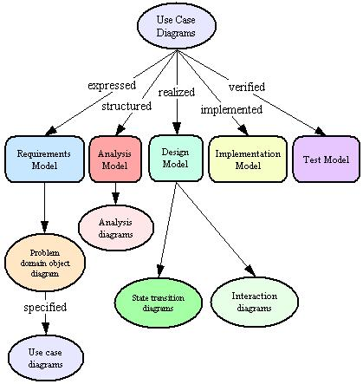

- OBJECT-ORIENTED SOFTWARE ENGINEERING LIFE CYCLE

Requirements Engineering:

o requirements gathering,

o Object oriented analysis and o specification

OO Design:

o architectural design o detailed design

o both require the transformation of functional requirements into OO design elements

Implementation or Coding:

o Programming using OO programming languages and tools.

Testing:
o unit testing; test methods within each object

o integration testing; test collaborations between objects

- system testing; test the entire system as a collection of objects

  - acceptance testing; test for standards and customer satisfaction

- UNIFIED PROCESS MODEL

Elaborat ion
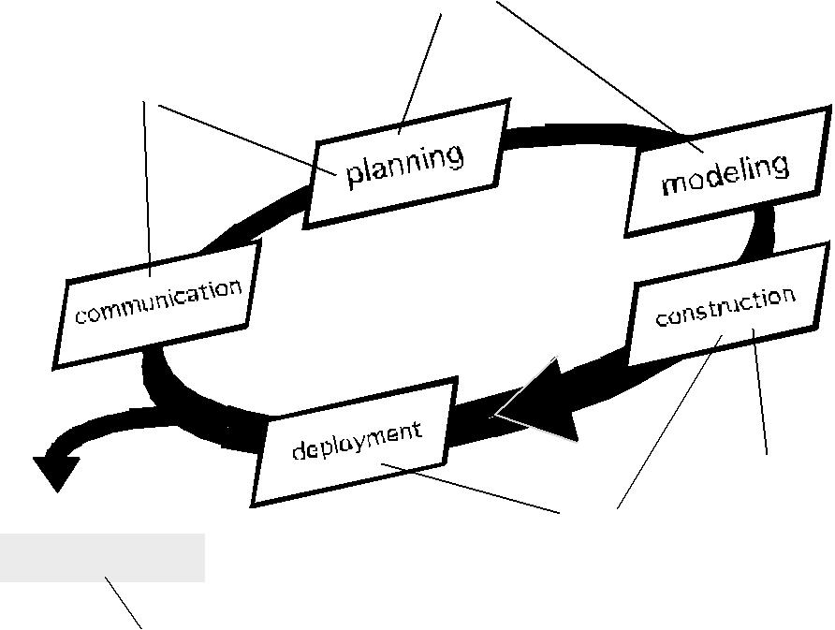

Incept ion

Release

soft ware increment

construction

t ransit ion

production

Iterative and Incremental:

o The Unified Process is an iterative and incremental development process.

- The Elaboration, Construction and Transition phases are divided into a series of timeboxed iterations.

- Each iteration results in an increment, which results in improved functionality .

Use Case Driven:

- In the Unified Process, use cases are used to capture the functional requirements and to define the contents of the iterations.

Risk Focused

- The Unified Process requires the project team to focus on the most critical risks early in the project life cycle.

o The deliverables of each iteration, especially in the Elaboration phase, must be selected in order to ensure that the greatest risks are addressed first.

Introduction to UML

UML is a language used for object-oriented analysis and design.

UML includes a set of graphical notation techniques to create visual models of software systems.

Three developers of UML are Grady Booch, Ivar Jacobson and James Rumbaugh.

UML is a language for visualizing, specifying, constructing, documenting.

UML is not a development method. It is designed to be compatible with the object-oriented software development methods.

- VIEWS IN UML

1. Functional View:

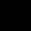 This view describes functional requirements of the system.

Use case diagrams give static functional view for functions and static relationships.
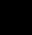 Activity diagrams give dynamic functional view.

- Static Structural View:
The class and object diagrams give the structural view of system.

3. Behavioral (dynamic structural) view:

Interaction diagrams- collaboration diagrams and sequence diagrams describe sequences of interactions between objects.

State transition diagrams show state-based behavior of objects.

4. Architectural View:

This view describes logical and physical structure.

Component diagrams and deployment diagrams are used in this view.
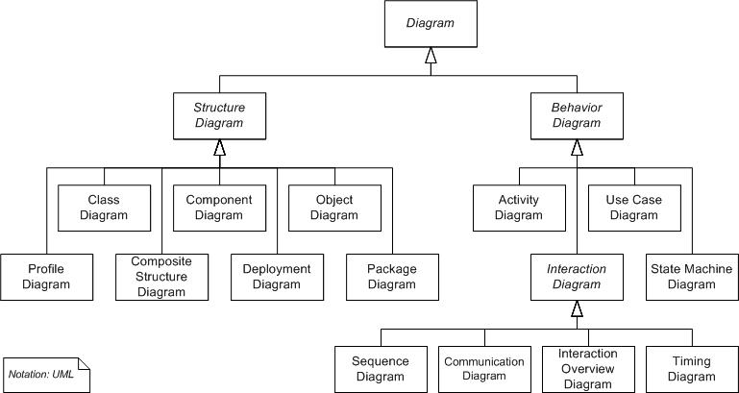

- UML DIAGRAMS

Diagrams are the heart of UML. These diagrams are broadly categorized as structural and behavioral diagrams.

Structural diagrams are consists of static diagrams like class diagram, object diagram etc.

Behavioral diagrams are consists of dynamic diagrams like sequence diagram, collaboration diagram etc.

The static and dynamic nature of a system is visualized by using these diagrams.

Class diagrams:

Class diagrams are the most popular UML diagrams used by the object oriented community. It describes the objects in a system and their relationships. Class diagram consists of attributes and functions.

A single class diagram describes a specific aspect of the system and the collection of class diagrams represents the whole system. Basically the class diagram represents the static view of a system.

Class diagrams are the only UML diagrams which can be mapped directly with object oriented languages. So it is widely used by the developer community.

Object Diagram:

An object diagram is an instance of a class diagram. So the basic elements are similar to a class diagram. Object diagrams are consists of objects and links. It captures the instance of the system at a particular moment.

Object diagrams are used for prototyping, reverse engineering and modeling practical scenarios.

Component Diagram:

Component diagrams are special kind of UML diagram to describe static implementation view of a system. Component diagrams consist of physical components like libraries, files, folders etc.

This diagram is used from implementation perspective. More than one component diagrams are used to represent the entire system. Forward and reverse engineering techniques are used to make executables from component diagrams.

Deployment Diagram:

Component diagrams are used to describe the static deployment view of a system. These diagrams are mainly used by system engineers.

Deployment diagrams are consists of nodes and their relationships. An efficient deployment diagram is an integral part of software application development.

Use Case Diagram;

Use case diagram is used to capture the dynamic nature of a system. It consists of use cases, actors and their relationships. Use case diagram is used at a high level design to capture the requirements of a system.

So it represents the system functionalities and their flow. Although the use case diagrams are not a good candidate for forward and reverse engineering but still they are used in a slightly differently way to model it.

Interaction Diagram:

Interaction diagrams are used for capturing dynamic nature of a system. Sequence and collaboration diagrams are the interaction diagrams used for this purpose.

Sequence diagrams are used to capture time ordering of message flow and collaboration diagrams are used to understand the structural organization of the system. Generally a set of sequence and collaboration diagrams are used to model an entire system.

Statechart Diagram:

Statechart diagrams are one of the five diagrams used for modeling dynamic nature of a system. These diagrams are used to model the entire life cycle of an object. Activity diagram is a special kind of Statechart diagram.

State of an object is defined as the condition where an object resides for a particular time and the object again moves to other states when some events occur. Statechart diagrams are also used for forward and reverse engineering.

Activity Diagram:

Activity diagram is another important diagram to describe dynamic behaviour. Activity diagram consists of activities, links, relationships etc. It models all types of flows like parallel, single, concurrent etc.

Activity diagram describes the flow control from one activity to another without any messages. These diagrams are used to model high level view of business requirements.

 

 

 

3

USE CASE DIAGRAMS

Unit Structure

- Introduction
- Requirement capture with use case
- Building blocks of use case diagram
- Actors
- Dependencies
- Generalizations

- INTRODUCTION

To model a system the most important aspect is to capture the dynamic behavior. To clarify a bit in details, dynamic behavior means the behaviour of the system when it is running /operating.

So only static behaviour is not sufficient to model a system rather dynamic behaviour is more important than static behaviour. In UML there are five diagrams available to model dynamic nature and use case diagram is one of them. Now as we have to discuss that the use case diagram is dynamic in nature there should be some internal or external factors for making the interaction.

These internal and external agents are known as actors. So use case diagrams are consists of actors, use cases and their relationships. The diagram is used to model the system/subsystem of an application. A single use case diagram captures a particular functionality of a system.

So to model the entire system numbers of use case diagrams are used.

- REQUIREMENT CAPTURE WITH USE CASE

The purpose of use case diagram is to capture the dynamic aspect of a system. But this definition is too generic to describe the purpose.

Because other four diagrams (activity, sequence, collaboration and Statechart) are also having the same purpose. So we will look into some specific purpose which will distinguish it from other four diagrams.

Use case diagrams are used to gather the requirements of a system including internal and external influences. These requirements are mostly design requirements. So when a system is analyzed to gather its functionalities use cases are prepared and actors are identified.

Now when the initial task is complete use case diagrams are modelled to present the outside view.

So in brief, the purposes of use case diagrams can be as follows:

- BUILDING BLOCKS OF USE CASE DIAGRAM

As UML describes the real time systems it is very important to make a conceptual model and then proceed gradually. Conceptual model of UML can be mastered by learning the following three major elements:

UML building blocks

Rules to connect the building blocks Common mechanisms of UML

This chapter describes all the UML building blocks. The building blocks of UML can be defined as:

Things Relationships Diagrams

(1) Things:

Things are the most important building blocks of UML. Things can be: Structural

Behavioral

Grouping Annotational

Structural things:

The Structural things define the static part of the model. They represent physical and conceptual elements. Following are the brief descriptions of the structural things.

Class:
Class represents set of objects having similar responsibilities.
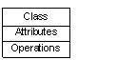

Interface:

Interface defines a set of operations which specify the responsibility of a class.
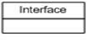

Collaboration:
Collaboration defines interaction between elements.
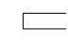

Use case:

Use case represents a set of actions performed by a system for a specific goal.
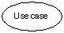

Component:
Component describes physical part of a system.
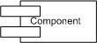

Node:
A node can be defined as a physical element that exists at run time.
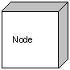

Behavioral things:

A behavioral thing consists of the dynamic parts of UML models. Following are the behavioral things:

Interaction:

Interaction is defined as a behavior that consists of a group of messages exchanged among elements to accomplish a specific task.
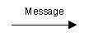

State machine:

State machine is useful when the state of an object in its life cycle is important. It defines the sequence of states an object goes through in response to events. Events are external factors responsible for state change.
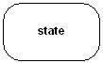

Grouping things:

Grouping things can be defined as a mechanism to group elements of a UML model together. There is only one grouping thing available:

Package:

Package is the only one grouping thing available for gathering structural and behavioral things.
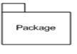

Annotational things:

Annotational things can be defined as a mechanism to capture remarks, descriptions, and comments of UML model elements. Note is the only one Annotational thing available.

Note:
A note is used to render comments, constraints etc of an UML element.
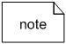

(2) Relationship :

Relationship is another most important building block of UML. It shows how elements are associated with each other and this association describes the functionality of an application.

There are four kinds of relationships available.

Dependency:

Dependency is a relationship between two things in which change in one element also affects the other one.
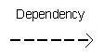

Association:

Association is basically a set of links that connects elements of an UML model. It also describes how many objects are taking part in that relationship.
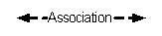

Generalization:

Generalization can be defined as a relationship which connects a specialized element with a generalized element. It basically describes inheritance relationship in the world of objects.
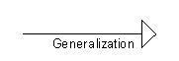

Realization:

Realization can be defined as a relationship in which two elements are connected. One element describes some responsibility which is not implemented and the other one implements them. This relationship exists in case of interfaces.
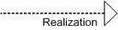

(3) UML Diagrams:

UML diagrams are the ultimate output of the entire discussion. All the elements, relationships are used to make a complete UML diagram and the diagram represents a system.

The visual effect of the UML diagram is the most important part of the entire process. All the other elements are used to make it a complete one.

UML includes the following nine diagrams and the details are described in the following chapters.

- Class diagram
- Object diagram
- Use case diagram
- Sequence diagram
- Collaboration diagram
- Activity diagram
- Statechart diagram
- Deployment diagram
- Component diagram

We would discuss all these diagrams in subsequent chapters of this book.

- ACTORS

An actor is a user or external system with which a system being modeled interacts. For example, our project management system involves various types of users, including project managers, resource managers, human resources, and system administrators. These users are all actors.

An actor is external to a system, interacts with the system, may be a human user or another system, and has goals and responsibilities to satisfy in interacting with the system. Actors address the question of who and what interacts with a system. In the UML, an actor is shown as a "stick figure" icon, or as a class marked with the actor keyword and labeled with the name of the actor class.

Following figure shows various actors associated with the project management system:

A project manager

Responsible for ensuring that a project delivers a quality product within specified time and cost, and within specified resource constraints

A resource manager

Responsible for ensuring that trained and skilled human resources are available for projects

A human resource

Responsible for ensuring that worker skills are maintained, and that quality work is completed for a project

A system administrator

Responsible for ensuring that a project management system is available for a project

A backup system

Responsible for housing backup data for a project management system
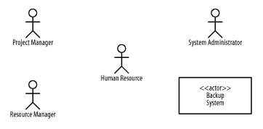

Use case guidelines for use case models

Use case diagrams are considered for high level requirement analysis of a system. So when the requirements of a system are analyzed the functionalities are captured in use cases.

So we can say that uses cases are nothing but the system functionalities written in an organized manner. Now the second things

which are relevant to the use cases are the actors. Actors can be defined as something that interacts with the system.

The actors can be human user, some internal applications or may be some external applications. So in a brief when we are planning to draw an use case diagram we should have the following items identified.

Functionalities to be represented as an use case
Actors
Relationships among the use cases and actors.

Use case diagrams are drawn to capture the functional requirements of a system. So after identifying the above items we have to follow the following guidelines to draw an efficient use case diagram.

The name of a use case is very important. So the name should be chosen in such a way so that it can identify the functionalities performed.

Give a suitable name for actors.
Show relationships and dependencies clearly in the diagram.

Do not try to include all types of relationships. Because the main purpose of the diagram is to identify requirements.

Use note when ever required to clarify some important points.

The following is a sample use case diagram representing the order management system. So if we look into the diagram then we will find three use cases (Order, SpecialOrder and NormalOrder) and one actor which is customer.

The SpecialOrder and NormalOrder use cases are extended from Order use case. So they have extends relationship. Another important point is to identify the system boundary which is shown in the picture. The actor Customer lies outside the system as it is an external user of the system.
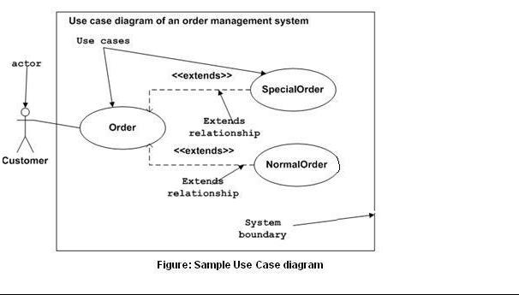

- DEPENDENCIES

A model may have many use cases, so how do we organize the use cases that define what a system should do? And how do we use this information about use cases to determine how best to execute a project while considering how use cases are related to one another, including what some use cases might have in common, and also taking into account use cases that are options of other use cases? Specialized types of dependencies, called include and extend dependencies,

address these questions; The next few sections discuss these specialized types of dependencies.

Include Dependencies

Perhaps we wish to log the activities of project managers, resources managers, and system administrators as they interact with the project management system. Figure A below elaborates on the use cases and figure B show that the activities of the project manager, resource managers, and system administrators are logged when they are performing the use cases shown in the diagram. Thus, logging activities are common to these three use cases. We can use an include dependency to address this type of situation by factoring out and reusing common behavior from multiple use cases.

Figure A.Use cases with common behavior
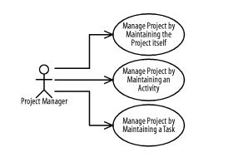

An include dependency from one use case (called the base use case) to another use case (called the inclusion use case) indicates that the base use case will include or call the inclusion use case. A use case may include multiple use cases, and it may be included in multiple use cases. An include dependency is shown as a dashed arrow from the base use case to the inclusion use case marked with the include keyword. The base use case is responsible for identifying where in its behavior sequence or at which step to include the inclusion use case. This identification is not done in the UML diagram, but rather in the textual description of the base use case.

B refines A using include dependencies. The Log Activity use case is common to the Manage Project, Manage Resource, and Administer System use cases, so it is factored out and included by these use cases.

Figure B. Include dependencies
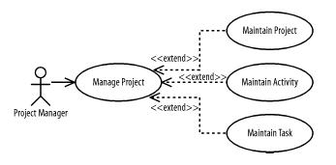

You can use an include dependency when a use case may be common to multiple other use cases and is therefore factored out of the different use cases so that it may be reused. The Log Activity use case in B is included in the Manage Project, Manage Resource, and Administer System use cases. Consequently, you must analyze and develop that use case before you develop the three use cases that depend on it.

Extend Dependencies

Projects are made of activities, and activities are made of tasks. Figure C elaborates the Manage Project use case and shows that a project manager may manage projects by maintaining the project itself, its activities, or its tasks. Thus, maintaining the project, its activities, and its tasks are options of managing a project. You can use an extend dependency to address this situation by factoring out optional behavior from a use case.

Figure C. Use cases with optional behavior
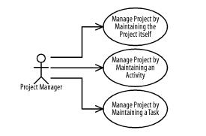

An extend dependency from one use case (called the extension use case) to another use case (called the base use case) indicates that the extension use case will extend (or be inserted into) and augment the base use case. A use case may extend multiple use cases, and a use case may be extended by multiple use cases. An extend dependency is shown as a dashed arrow from the extension use case to the base use case marked with the extend keyword. The base use case is responsible for identifying at which steps in its behavior sequence the extending use cases may be inserted.

Figure D refines Figure C using extend dependencies. The Maintain Project, Maintain Activity, and Maintain Task use cases are options of the Manage Project use case, so Manage Project is factored out and extends those three use cases.

Figure D. Simple extend dependencies
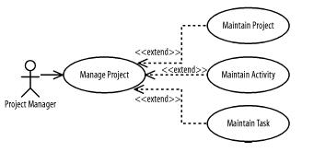

The location in a base use case at which another behavior sequence may be inserted is called an extension point. Extension points for a use case may be listed in a compartment labeled "Extension Points" where each extension point is shown inside the compartment with an extension-point name followed by a colon followed by a suitable description of the location of the extension point in the use case's

behavior sequence. Locations may be described as being before, after, or in-the-place-of a step in the base use case's behavior sequence. For example, the Manage Project use case may have a behavior sequence for finding a project on which to work followed by an extension point named Project Selected followed by another behavior. The Project Selected extension point may be described as occurring after a project is found but before it is actually worked on.

An extend dependency is responsible for defining when an extension use case is inserted into the base use case by specifying a condition that must be satisfied for the insertion to occur. The condition may be shown following the extend keyword enclosed within square brackets followed by the extension point name enclosed in parentheses. For example, other use cases may be inserted into the Project Selected extension point just described for the Manage Project use case. Such behavior sequences may include reviewing and updating project information, or selecting a specific version of a project before managing the details of the project in the succeeding behavior sequences.

- GENERALIZATIONS

Actors may be similar in how they use a system; for example, project managers, resource managers, and system administrators may log in and out of our project management system. Use cases may be similar in the functionality provided to users; for example, a project manager may publish a project's status in two ways: by generating a report to a printer or by generating a web site on a project web server.

Given that there may be similarities between actors and use cases, how do we organize the use cases that define what a system should do? And how do we use the information about similarities between actors and use cases to determine how best to execute a project? Specialized types of generalizations, called actor and use case generalizations, address these questions.

Actor Generalizations

Figure E shows that project managers, resource managers, and system administrators may log in and out of the project management system. Thus, logging in and out is common to these actors. Actor generalizations address such situations by factoring out and reusing similarities between actors.

Figure E
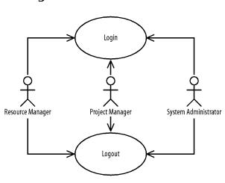

An actor generalization from a more specific, or specialized, actor to a more general, or generalized, actor indicates that instances of the more specific actor may be substituted for instances of the more general

actor. An actor may specialize multiple actors, and an actor may be specialized by multiple actors. An actor generalization between actors is shown as a solid-line path from the more specific actor to the more general actor, with a large hollow triangle at the end of the path connected to the more general actor.

Figure F refines Figure Eusing actor generalizations between actors. A human resource initiates the Login and Logout use cases. Project managers, resource managers, and system administrators are human resources.

Figure F
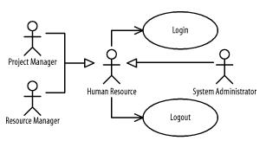

Use an actor generalization between actors when one actor is similar to another, but has specific interactions in which it participates or initiates. For example, any human resource may log in and out, but project managers, resources managers, and system administrators make more specialized use of the project management system. Because

the Project Manager, Resource Manager, and System Administrator actors are

specialized Human Resource actors, they benefit from the use cases in which the Human Resource actor is involved. Therefore, by developing the Login and Logout use cases, we provide the functionality described by those use cases for all the actors of our system.

Use-Case Generalizations

Figure G shows that a project manager may publish a project's status in two ways: by generating a report to a printer or by generating a web site on a project web server. Thus, publishing a project's status and all the processing involved in collecting and preparing the data for publication is common to these use cases. You can use a use-case generalization to address this situation by factoring out and reusing similar behavior from multiple use cases.
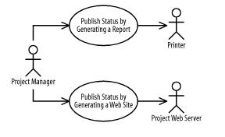

Figure G

A use-case generalization from a more specific, or specialized, use case to a more general, or generalized, use case indicates that the more specific use case receives or inherits the actors, behavior sequences, and extension points of the more general use case, and that instances of the more specific use case may be substituted for instances of the more general use case. The specific use case may include other
actors, define new behavior sequences and extension points, and modify or specialize the behavior sequences it receives or inherits. A use case may specialize multiple use cases, and a use case may be specialized by multiple use cases. A use-case generalization between use cases is shown as a solid-line path from the more specific use case to the more general use case, with a large hollow triangle at the end of the path connected to the more general use case.



4

ACTIVITY DIAGRAM

Unit Structure

- Introduction
- Overview
- Elements of an Activity diagram
- Action State\ Activity state
- Object Node
- Control Node
- How to draw Activity Diagram?

- INTRODUCTION

This chapter focuses on activity diagrams, which depict the activities and responsibilities of elements that make up a system. First, we introduce activity diagrams and how they are used. Next, we discuss action states, activity state and their details. Finally, we go over control, flows and their details. we include suggestions relating to activity diagrams.

Activity modeling is a specialized type of behavioral modeling concerned with modeling the activities and responsibilities of elements. You usually apply activity modeling in conjunction with sequence and collaboration modeling to explore the activities and responsibilities of interacting and collaborating elements.

- OVERVIEW

Activity diagram is another important diagram in UML to describe dynamic aspects of the system.

Activity diagram is basically a flow chart to represent the flow form one activity to another activity. The activity can be described as an operation of the system.

So the control flow is drawn from one operation to another. This flow can be sequential, branched or concurrent. Activity diagrams deals with all type of flow control by using different elements like fork, join etc.

The basic purposes of activity diagrams are similar to other four diagrams. It captures the dynamic behavior of the system.

Other four diagrams are used to show the message flow from one object to another but activity diagram is used to show message flow from one activity to another.

Activity is a particular operation of the system. Activity diagrams are not only used for visualizing dynamic nature of a system but they are also used to construct the executable system by using forward and reverse engineering techniques. The only missing thing in activity diagram is the message part.

It does not show any message flow from one activity to another. Activity diagram is some time considered as the flow chart. Although the diagrams looks like a flow chart but it is not. It shows different flow like parallel, branched, concurrent and single.

So the purposes can be described as:

Draw the activity flow of a system.
Describe the sequence from one activity to another.

Describe the parallel, branched and concurrent flow of the system.

- ELEMENTS OF AN ACTIVITY DIAGRAM

An Activity diagram consists of the following behavioral elements:
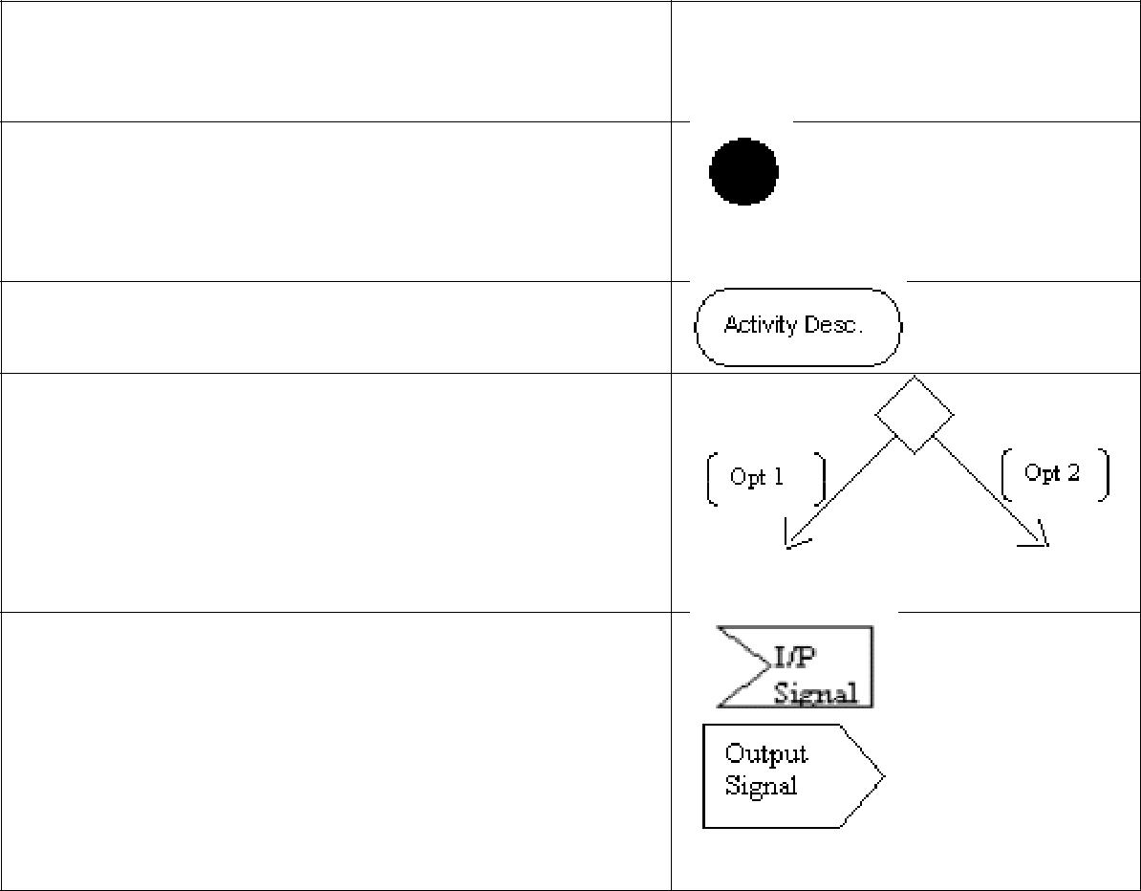
Element and its description | Symbol

Initial Activity: This shows the starting point or first activity of the flow. Denoted by a solid circle. This is similar to the notation used for Initial State.

Activity: Represented by a rectangle with rounded (almost oval) edges.

Decisions: Similar to flowcharts, a logic where a decision is to be made is depicted by a diamond, with the options written on either sides of the arrows emerging from the diamond, within box brackets.

Signal: When an activity sends or receives a message, that activity is called a signal. Signals are of two types: Input signal (Message receiving activity) shown by a concave polygon and Output signal (Message sending activity) shown by a convex polygon.

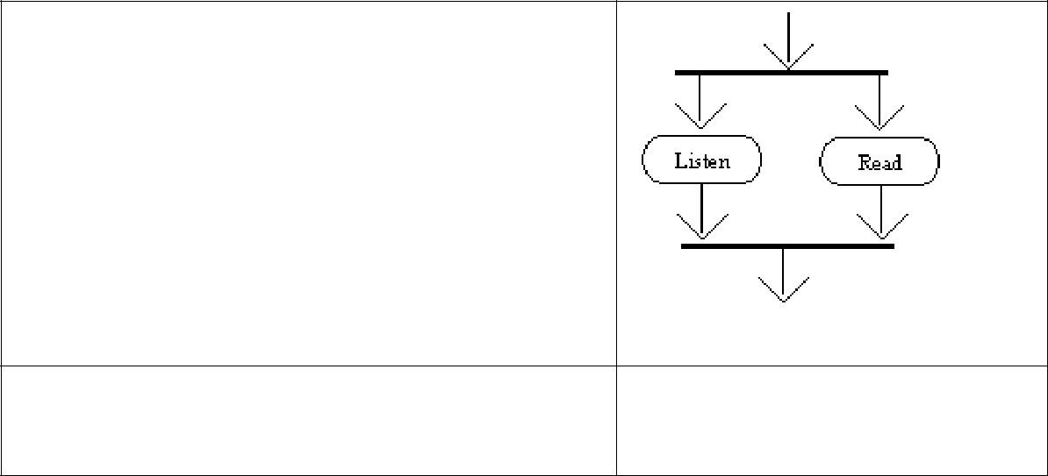
Concurrent Activities: Some activities occur simultaneously or in parallel. Such activities are called concurrent activities. For example, listening to the lecturer and looking at the blackboard is a parallel activity. This is represented by a horizontal split (thick dark line) and the two concurrent activities next to each other, and the horizontal line again to show the end of the parallel activity.

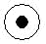
Final Activity: The end of the Activity diagram is shown by a bull's eye symbol, also called as a final activity
diagram is shown by a bull's eye symbol, also called as a final activity

- ACTION STATE\ ACTIVITY STATE

As elements communicate with one another within a society of objects, each element has the responsibility of appropriately reacting to the communications it receives. An action state represents processing as an element fulfills a responsibility. There are various types of action states, including simple, initial, and final action states. The next few sections discuss these different types of action states.

Simple Action States

A simple action state represents processing. For example, the project management system may have the following simple action states:

Project Manager Enters Report Criteria : Indicates that the project manager enters report criteria

Project Management System Generates Report : Indicates that the project management system generates a report

Printer Prints Report : Indicates that the printer prints the report

In the UML, an action state is shown as a shape with a straight top and bottom and convex arcs on the two sides, and is labeled with the name of an operation or a description of the processing. Figure A shows the various action states associated with the project management system.

Figure A. Simple action states
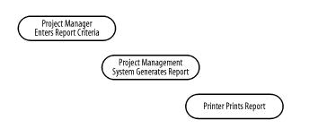
XXX

Initial and Final Action States

An initial action state indicates the first action state on an activity diagram. In the UML, an initial action state is shown using a small solid filled circle. A final action state indicates the last action state on an activity diagram. In the UML, a final action state is shown using a circle surrounding a small solid filled circle (a bull's eye). Figure B updates Figure A with an initial and final action state. An activity diagram may have only one initial action state, but may have any number of final action states.

Figure B. Simple, initial, and final action states
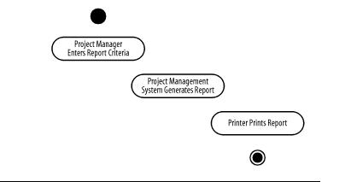

- OBJECT NODE

An object node is an activity node that is part of defining object flow in an activity. It indicates that an instance of a particular Classifier, possibly in a particular state, may be available at a particular point in the activity. Object nodes can be used in a variety of ways, depending on where objects are flowing from and to.

Object nodes are notated as rectangles. A name labeling the node is placed inside the symbol, where the name indicates the type of the object node, or the name and type of the node in the format "name:type."
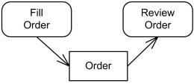

Object flow of Orders between Fill Order and Review Order actions

The name can also be qualified by a state or states, which is to be written within brackets below the name of the type. Upper bounds, ordering, and control type other than the defaults are notated in braces underneath the object node

- CONTROL NODE

Control node is an activity node used to coordinate the flows between other nodes. It includes:

Initial Node

Initial node is a control node at which flow starts when the activity is invoked.

A control token is placed at the initial node when the activity starts, but not in initial nodes in structured nodes contained by the activity. Tokens in an initial node are offered to all outgoing edges. For convenience, initial nodes are an exception to the rule that control nodes cannot hold tokens if they are blocked from moving downstream, for example, by guards.

Activity may have more than one initial node. In this case, invoking the activity starts multiple flows, one at each initial node.

Note that flows can also start at other nodes, so initial nodes are not required for an activity to start execution.

Initial nodes are shown as a small solid circle.
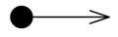

Activity initial node.

Flow Final Node

Flow final node is a control final node that terminates a flow. It destroys all tokens that arrive at it but has no effect on other flows in the activity. Flow final was introduced in UML 2.0.

The notation for flow final node is small circle with X inside.
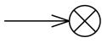

Flow final node.

Activity Final Node

Activity final node is a control final node that stops all flows in an activity. Activity final was introduced in UML 2.0.

An activity may have more than one activity final node. The first one reached stops all flows in the activity. A token reaching an activity final node terminates the activity. In particular, it stops all executing actions in the activity, and destroys all tokens in object nodes, except in the output activity parameter nodes. Terminating the execution of synchronous invocation actions also terminates whatever behaviors they are waiting on for return. Any behaviors invoked asynchronously by the activity are not affected. If it is not desired to abort all flows in the activity, use flow final instead.

Activity final nodes are shown as a solid circle with a hollow circle inside. It can be thought of as a goal notated as "bull‘s eye," or target.
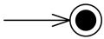

Activity final node.
XXXII

Decision Node

Decision node is a control node that accepts tokens on one or two incoming edges and selects one outgoing edge from one or more outgoing flows. Decision nodes were introduced in UML to support conditionals in activities.

The edges coming into and out of a decision node, other than the decision input flow (if any), must be either all object flows or all control flows.

Each token arriving at a decision node can traverse only one outgoing edge. Tokens are not duplicated. Each token offered by the incoming edge is offered to the outgoing edges.

Which of the edges is actually traversed depends on the evaluation of the guards on the outgoing edges. The order in which guards are evaluated is not defined, i.e. we should not rely on any visual or text description order.

The notation for a decision node is a diamond-shaped symbol.
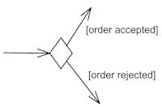

Decision node with two outgoing edges with guards.

The modeler should arrange that each token only be chosen to traverse one outgoing edge. For decision points, a predefined guard "else" may be defined for at most one outgoing edge.
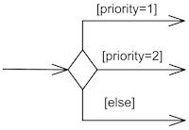

Decision node with three outgoing edges and [else] guard.

Decision can have decision input behavior specified. Decision input behaviors were introduced in UML to avoid redundant recalculations in guards.

In this case each data token is passed to the behavior before guards are evaluated on the outgoing edges. The behavior is invoked without input for control tokens. The output of the behavior is available to each guard. Because the behavior is used during the process of offering tokens to outgoing edges, it may be run many times on the same token before the token is accepted by those edges. This means the behavior cannot have side effects.

Decision input behavior is specified by the keyword «decisionInput» and some decision behavior or condition placed in a note symbol, and attached to the appropriate decision node.
XXXIII
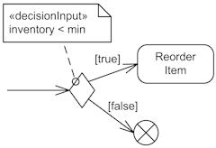

Decision node with decision input behavior.

Decision may also have decision input flow. In this case the tokens offered on the decision input flow that are made available to the guard on each outgoing edge determine whether the offer on the regular incoming edge is passed along that outgoing edge.

A decision input flow is specified by the keyword «decisionInputFlow» annotating that flow.
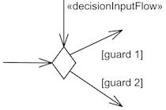

Decision node with decision input flow.

If there are both a decision input behavior as well as decision input flow, the token offered on the decision input flow is passed to the behavior (as the only argument if the regular incoming edge is control flow, as the second argument if it is an object flow). Decision nodes with the additional decision input flow offer tokens to outgoing edges only when one token is offered on each incoming edge.

Merge Node

Merge node is a control node that brings together multiple incoming alternate flows to accept single outgoing flow. There is no joining of tokens. Merge should not be used to synchronize concurrent flows.

For example, if a decision is used after a fork, the two flows coming out of the decision need to be merged into one before going to a join; otherwise, the join will wait for both flows, only one of which will arrive.

All edges coming into and out of a merge node must be either object flows or control flows.

The notation for a merge node is a diamond-shaped symbol with two or more edges entering it and a single activity edge leaving it.
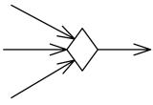

Merge node with three incoming edges and a single outgoing edge

The functionality of merge node and decision node can be combined by using the same node symbol, as illustrated below. This
XXXIV

case maps to a model containing a merge node with all the incoming edges shown in the diagram and one outgoing edge to a decision node that has all the outgoing edges shown in the diagram.
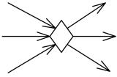

Merge node and decision node combined using the same symbol

Fork Node

Fork node is a control node that has one incoming edge and multiple outgoing edges and is used to split incoming flow into multiple concurrent flows. Fork nodes are introduced to support parallelism in activities. As compared to UML 1.5, UML 2.0 activity forks model unrestricted parallelism.

Tokens arriving at a fork are duplicated across the outgoing edges. If at least one outgoing edge accepts the token, duplicates of the token are made and one copy traverses each edge that accepts the token. The outgoing edges that did not accept the token due to failure of their targets to accept it, keep their copy in an implicit FIFO queue until it can be accepted by the target. The rest of the outgoing edges do not receive a token.

The notation for a fork node is a line segment with a single activity edge entering it, and two or more edges leaving it.
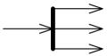

Fork node with a single activity edge entering it, and three edges leaving it.

The functionality of join node and fork node can be combined by using the same node symbol. This case maps to a model containing a join node with all the incoming edges shown in the diagram and one outgoing edge to a fork node that has all the outgoing edges shown in the diagram.
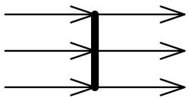

Combined join node and fork node.

If guards are used on edges outgoing from forks, the modelers should ensure that no downstream joins depend on the arrival of tokens passing through the guarded edge. If that cannot be avoided, then a decision node should be introduced to have the guard, and shunt the token to the downstream join if the guard fails.

Join Node

Join node is a control node that has multiple incoming edges and one outgoing edge and is used to synchronize incoming concurrent flows. Join nodes are introduced to support parallelism in activities.

The notation for a join node is a line segment with several activity edges entering it, and only one edge leaving it.
XXXV
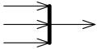

Join node with three activity edges entering it, and a single edge leaving it.

The functionality of join node and fork node can be combined by using the same node symbol. This case maps to a model containing a join node with all the incoming edges shown in the diagram and one outgoing edge to a fork node that has all the outgoing edges shown in the diagram.

Combined join node and fork node.

Join nodes have a join specification which is Boolean value specification using the names of the incoming edges to specify the conditions under which the join will emit a token.

The join specification is evaluated whenever a new token is offered on any incoming edge. The evaluation is not interrupted by any new tokens offered during the evaluation, nor are concurrent evaluations started when new tokens are offered during an evaluation.

The default join specification is the reserved string "and". It is equivalent to a specification that requires at least one token offered on each incoming edge.

Join specifications are shown in curly braces near the join node as joinSpec=....
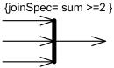

Join node with join specification shown in curly braces.

- HOW TO DRAW ACTIVITY DIAGRAM?

Activity diagrams are mainly used as a flow chart consists of activities performed by the system. But activity diagram are not exactly a flow chart as they have some additional capabilities. These additional capabilities include branching, parallel flow, swimlane etc.

Before drawing an activity diagram we must have a clear understanding about the elements used in activity diagram. The main element of an activity diagram is the activity itself. An activity is a function performed by the system. After identifying the activities we need to understand how they are associated with constraints and conditions.

So before drawing an activity diagram we should identify the following elements:
XXXVI

Activities

Association

Conditions

Constraints

Once the above mentioned parameters are identified we need to make a mental layout of the entire flow. This mental layout is then transformed into an activity diagram.

e.g. The following is an example of an activity diagram for order management system. In the diagram four activities are identified which are associated with conditions. One important point should be clearly understood that an activity diagram cannot be exactly matched with the code. The activity diagram is made to understand the flow of activities and mainly used by the business users.

The following diagram is drawn with the four main activities:

Send order by the customer

Receipt of the order

Confirm order

Dispatch order

After receiving the order request condition checks are performed to check if it is normal or special order. After the type of order is identified dispatch activity is performed and that is marked as the termination of the process.
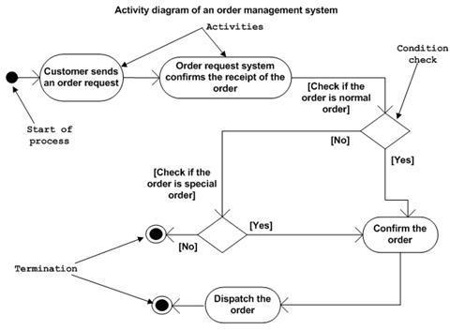

Action decomposition (rake)

Often, an action can be decomposed into a sequence of other actions. As a result, the action is implemented by a subactivity. When we implement an action via another activity, we place a rake in the node that represents the action. This rake indicates that a subactivity diagram implements the action.
XXXVII

A subactivity diagram
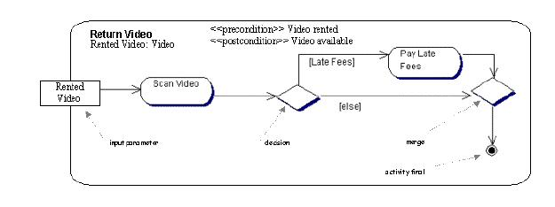

Partition Swimlanes:

As discussed earlier in this chapter, a swimlane is a visual region in an activity diagram that indicates the element that has responsibility for action states within the region. For example, the project management system may have the following swimlanes, which are illustrated in following figure

Project Manager

Shows the action states that are the responsibility of a project manager. The swimlane makes it obvious that the project manager is responsible for entering data, thus the rather cumbersome action state name of Project Manager Enters Data may be shortened to Enter Data.

Project Management System

Shows the action states that are the responsibility of the project management system. Again, because the swimlane makes it obvious who (or what, in this case) is generating information, the rather cumbersome action state name of Project Management System Generates Information may be shortened to Generate Information.

Printer

Shows the action states that are the responsibility of a printer. Because of this swimlane, the rather cumbersome action state name of Printer Prints Information may be shortened to Print Information.

Notice how the use of swimlanes allows me to rename the action states to omit the responsible element for each action state.

In the UML, a swimlane is shown as a visual region separated from neighboring swimlanes by vertical solid lines on both sides and labeled at the top with the element responsible for action states within the swimlane. Following figure shows the swimlanes associated with the project management system.
XXXVIII
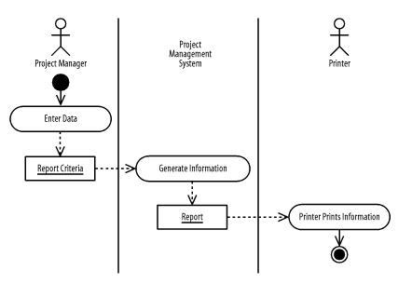



5

CLASS DIAGRAMS

Unit Structure

- Introduction
- Class
- Attributes and operations/methods
- Responsibilities of Classes
- Abstract Class
- Standard Class Stereotypes
- Dependency

- INTRODUCTION

Class diagram is UML structure diagram which shows structure of the designed system at the level of classes and interfaces, shows their features, constraints and relationships - associations, generalizations, dependencies, etc.

- CLASS

A class is a classifier which describes a set of objects that share the same
o features
o constraints
o semantics (meaning).

Class Diagrams

UML class diagrams model static class relationships that represent the fundamental architecture of the system. Note that these diagrams describe the relationships between classes, not those between specific objects instantiated from those classes. Thus the diagram applies to all the objects in the system.

A class diagram consists of the following features:

Classes: These titled boxes represent the classes in the system and contain information about the name of the class, fields,
XXXIX

methods and access specifiers. Abstract roles of the class in the system can also be indicated.

Interfaces: These titled boxes represent interfaces in the system and contain information about the name of the interface and its methods.

A class is shown as a solid-outline rectangle containing the class name, and optionally with compartments separated by horizontal lines containing features or other members of the classifier.

As class is the most widely used classifier, there is no need to add the "class" keyword in guillemets above the class name. Class name should be centered and in bold face, with the first letter of class name capitalized (if the character set supports upper case).
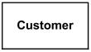

Class Customer - details suppressed

- ATTRIBUTES AND OPERATIONS/METHODS

Features of a class are attributes and operations. When class is shown with three compartments, the middle compartment holds a list of attributes and the bottom compartment holds a list of operations. Attributes and operations should be left justified in plain face, with the first letter of the names in lower case.
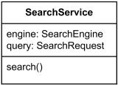

Class SearchService - analysis level details

Characteristics represented by feature may be of the classifier‘s instances considered individually (not static) or of the classifier itself (static). The same feature cannot be static in one context and non static in another.

With regard to static features, two alternative semantics are recognized. Static feature may have:

o different values for different featuring classifiers, or o the same value for all featuring classifiers.

Static features are underlined - but only the names. An ellipsis (...) as the final element of a list of features indicates that additional features exist but are not shown in that list.

Attributes of a class are represented by instances of Property that are owned by the class. Some of these attributes may represent the navigable ends of binary associations.

Objects of a class must contain values for each attribute that is a member of that class, in accordance with the characteristics of the attribute, for example its type and multiplicity.
XL
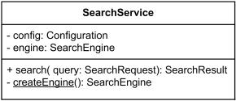

Class SearchService - implementation level details. The createEngine is static operation

Attributes or operations may be grouped by visibility. A visibility keyword or symbol in this case can be given once for multiple features with the same visibility.
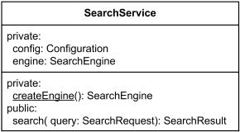

Class SearchService - attributes and operations grouped by visibility

Additional compartments may be provided to show other details, such as constraints, or just to divide features.

- RESPONSIBILITIES OF CLASSES

Knowing
- knowing about private encapsulated data
- knowing about related objects
- knowing about things it can derive or calculate

Doing
a. doing something itself, such as creating an object or doing

Calculation

- initiating action in other objects
- controlling and coordinating activities in other objects

Examples

a Sale is responsible for knowing its total (POS example) a Sale is responsible for creating SalesLineItems

- ABSTRACT CLASS

Abstract class was defined as class that can't be directly instantiated. Abstract class exists only for other classes to inherit from and to support reuse of the features declared by it. No object may be a direct instance of an abstract class, although an object may be an indirect instance of one through a subclass that is nonabstract.

We can probably relate definition of abstract classifier to abstract class. We may assume that in UML 2.x abstract class does not have complete declaration and "typically" can not be instantiated. An abstract
XLI

class is intended to be used by other classifiers (e.g., as the target of generalization generalization relationships).

Attempting to create an instance of an abstract class is undefined - some languages may make this action illegal, others may create a partial instance for testing purposes.

The name of an abstract class is shown in italics.
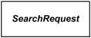

Class SearchRequest is abstract class

An abstract classifier can also be shown using the keyword {abstract} after or below the name.

- STANDARD CLASS STEREOTYPES

Standard class stereotypes include: «focus»

«auxiliary»
«type»
«utility»

«focus»

Focus is class that defines the core logic or control flow for one or more supporting classes. The supporting classes may be defined either explicitly using auxiliary classes or implicitly by dependency relationships.

Focus classes are typically used for specifying the core business logic or control flow of components during design phase.

«auxiliary»

Auxiliary is class that supports another more central or fundamental class, typically by implementing secondary logic or control flow. The class that the auxiliary supports may be defined either explicitly using a focus class or implicitly by a dependency relationship.

Auxiliary classes are typically used for specifying the secondary business logic or control flow of components during design phase.

«type»

Type is class that specifies a domain of objects together with the operations applicable to the objects, without defining the physical implementation of those objects.

Type may have attributes and associations. Behavioral specifications for type operations may be expressed using, for example, activity diagrams. An object may have at most one implementation class, however it may conform to multiple different types.

«utility»

Utility is class that has only class scoped static attributes and operations. As such, utility class usually has no instances.
XLII
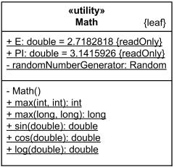

Math is utility class - having static attributes and operations (underlined)

Visibility of attributes and operations

Public (+): member of class is directly accessible to other objects; part of public interface

Private (-) : member is hidden from public use; only accessible to other members within the class

Protected (#): special visibility scope applicable to inheritance only

Relational among classes

A class may be involved in one or more relationships with other classes. A relationship can be one of the following types:

Inheritance (or Generalization):
- Represents an ―is-a‖ relationship.
- An abstract class name is shown in italics.

- SubClass1 and SubClass2 are specializations of SuperClass. Generalization
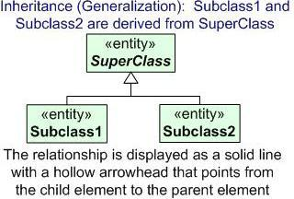

Association

• Simple association:
o A structural link between two peer classes.
o There is an association between Class1 and Class2
XLIII
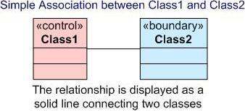

Associations can be one of the following two types or not specified.

Composition:

Represented by an association line with a solid diamond at the tail end. A composition models the notion of one object "owning" another and thus being responsible for the creation and destruction of another object. A special type of aggregation where parts are destroyed when the whole is destroyed.

Objects of Class2 live and die with Class1. Class2 cannot stand by itself.
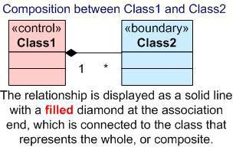

Aggregation:

Represented by an association line with a hollow diamond at the tail end. An aggregation models the notion that one object uses another object without "owning" it and thus is not responsible for its creation or destruction.

It is a special type of association. It represents a “partof” relationship.

Class2 is part of Class1.

Many instances (denoted by the *) of Class2 can be associated with Class1.

Objects of Class1 and Class2 have separate lifetimes.
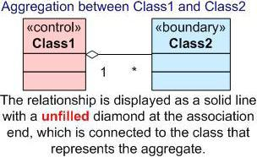
XLIV

- DEPENDENCY

A dotted line with an open arrowhead that shows one entity depends on the behavior of another entity. Typical usages are to represent that one class instantiates another or that it uses the other as an input parameter.

It exists between two classes if changes to the definition of one may cause changes to

the other (but not the other way around).

Class1 depends on Class 2
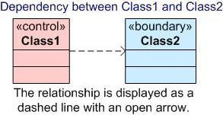

Here is an example of a UML class diagram that holds most of the more common features. The above diagram contains classes, interfaces, inheritance and implementation lines, aggregation lines lines, dependency lines and notes
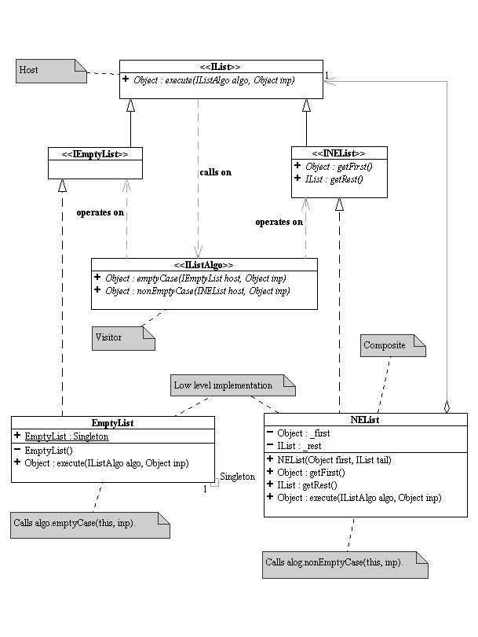

 

 

 

 

 
XLV

6

ASSOCIATION CLASSES

Unit Structure

- Associations
- Association Classes
- Association Ends
- Dependency

- ASSOCIATIONS

As discussed in earlier. Association defines a type of link and is a general relationship between classes. For example, the project management system involves various general relationships, including manage, lead, execute, input, and output between projects, managers, teams, work products, requirements, and systems. Consider, for example, how a project manager leads a team.

Binary associations

A binary association relates two classes. For example, one binary relationship in the project management system is between individual workers and their units of work, and another binary relationship is between individual workers and their work products.

In a UML class diagram, a binary association is shown as a solid-line path connecting the two related classes. A binary association may be labeled with a name. The name is usually read from left to right and top to bottom; otherwise, it may have a small black solid triangle next to it where the point of the triangle indicates the direction in which to read the name, but the arrow is purely descriptive, and the name of the association should be understood by the classes it relates.

Figure A shows various associations within the project management system using the most basic notation for binary associations. The associations in the figure are as follows:

A worker is responsible for work products and performs units of work

Units of work consume work products as input and produce work products as output.

Notice that a binary association should be named using a verb phrase.
XLVI

Figure A. Binary associations
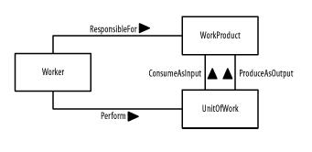

N-ary associations

An n-ary association relates three or more classes. For example, in the project management system, the use of a worker involves the worker, her units of work, and her associated work products.

In a UML class diagram, an n-ary association is shown as a large diamond with solid-line paths from the diamond to each class. An n-ary association may be labeled with a name. The name is read in the same manner as for binary associations, described in the previous section.

Figure B shows an n-ary association associated with the project management system using the most basic notation for n-ary associations. This association states that utilization involves workers, units of work, and work products. As with a binary association, an n-ary association is also commonly named using a verb phrase. However, this is not always the case — for example, the n-ary Utilization association shown in Figure B is described using a noun rather than a verb, because it is named from our perspective rather than the perspective of one of the classes. That is, from our perspective, we want to understand a worker's utilization relative to the other classes. From the worker's perspective, a worker is responsible for work products and performs units of work.

Figure B. N-ary association
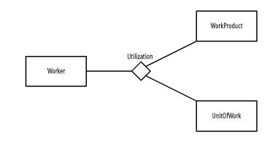

Qualified Association

A qualified association has an attribute compartment (a qualifier) on one end of a binary association (an association can be qualified on both ends but this is rare). The compartment contains one or more attributes that can serve as an index key for traversing the association from the qualified class via qualifier to the target class on the opposite association end
 |  |  |  | XLVII
For e.g.
 | Flight |  |  |  |  |  | 0..1
 | Flight |  | seat_number : String |  |  |  | 0..1 | Passenger
 | flight_number : String |  |  |  |  |  | 0..1 | Passenger
 | flight_number : String |  |  | departure : Date |  |  | 1..*

Ternary Association

So far I have only mentioned associations which involve two classes, however you can have associations which have more than two classes involved called n-ary associations, specifically one involving three classes is called a Ternary association.

Let's consider an example, below is shown a ternary association between Lecturer, Book and Module. What does this mean? Well it indicates that there is a clear association between a specific lecturer, book and module. For example with this diagram we could be able to discover that Lecturer Joan uses the book 'UML and spirituality' on the module 'modern theology'. In other words we are defining a set of three specific values (L,B,M) in contrast to two specific values for an association involving two classes.
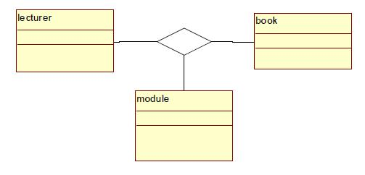

Reflexive associations

We have now discussed all the association types. As you may have noticed, all our examples have shown a relationship between two different classes. However, a class can also be associated with itself, using a reflexive association. This may not make sense at first, but remember that classes are abstractions. Following figure shows how an Employee class could be related to itself through the manager/manages role. When a class is associated to itself, this does not mean that a class's instance is related to itself, but that an instance of the class is related to another instance of the class.

Example of a reflexive association relationship
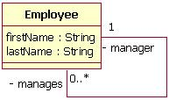
XLVIII

The relationship drawn in Figure 14 means that an instance of Employee can be the manager of another Employee instance. However, because the relationship role of "manages" has a multiplicity of 0..*; an Employee might not have any other Employees to manage.

- ASSOCIATION CLASSES

Association classes may be applied to both binary and n-ary associations. Similar to how a class defines the characteristics of its objects, including their structural features and behavioral features, an association class may be used to define the characteristics of its links, including their structural features and behavioral features. These types of classes are used when you need to maintain information about the relationship itself.

In a UML class diagram, an association class is shown as a class attached by a dashed-line path to its association path in a binary association or to its association diamond in an n-ary association. The name of the association class must match the name of the association.

Figure C shows association classes for the binary associations in Figure A using the most basic notation for binary association classes. The association classes track the following information:

The reason a worker is responsible for a work product The reason a worker performs a unit of work

A description of how a unit of work consumes a work product A description of how a unit of work produces a work product.

Figure C. Binary association classes
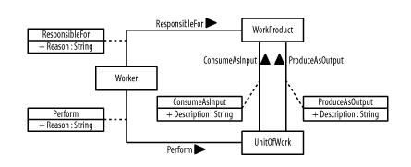

Figure D shows an association class for the n-ary association in Figure B using the most basic notation for n-ary association classes. The association class tracks a utilization percentage for workers, their units of work, and their associated work products.

Figure D. N-ary association class
XLIX
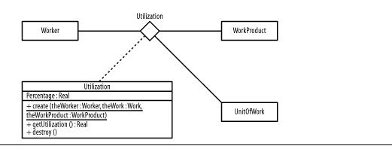

- ASSOCIATION ENDS

An association end is an endpoint of the line drawn for an association, and it connects the association to a class. An association end may include any of the following items to express more detail about how the class relates to the other class or classes in the association:

Rolename
Navigation arrow
Multiplicity specification
Aggregation or composition symbol
Qualifier

Rolenames

A rolename is optional and indicates the role a class plays relative to the other classes in an association, how the other classes "see" the class or what "face" the class projects to the other classes in the relationship. A rolename is shown near the end of an association attached to a class.

For example, a work product is seen as input by a unit of work where the unit of work is seen as a consumer by the work product; a work product is seen as output by a unit of work where the unit of work is seen as a producer by the work product, as shown in Figure 3-13. I will continue to discuss this figure in the next sections. I particularly captured significant detail in one figure so that you can see how much the UMC enables you to communicate in a figure such as this.

Figure E. Binary association ends
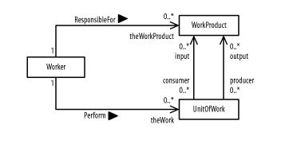

Navigation

Navigation is optional and indicates whether a class may be referenced from the other classes in an association. Navigation is shown as an arrow attached to an association end pointing toward the class in question. If no arrows are present, associations are assumed to be navigable in all directions, and all classes involved in the association may reference one another.
L

For example, given a worker, you can determine his work products and units of work. Thus, Figure E shows arrows pointing towards work product and units of work. Given a unit of work, you can determine its input and output work products; but given a work product, you are unable to identify which worker is responsible for it or which units of work reference it as input or output (as shown in Figure E by the lack of arrows pointing to the Worker class). Figure F shows navigation arrows applied to an n-ary association. Given a worker, you can reference his work products and units of work to determine his utilization, but given a work product or unit of work, you are unable to determine its utilization by a worker.

Figure F . N-ary association ends
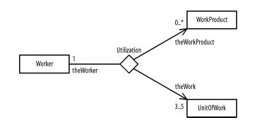

Multiplicity

Multiplicity (which is optional) indicates how many objects of a class may relate to the other classes in an association. Multiplicity is shown as a comma-separated sequence of the following:

Integer intervals
Literal integer values

Intervals are shown as a lower-bound .. upper-bound string in which a single asterisk indicates an unlimited range. No asterisks indicate a closed range. For example, 1 means one, 1..5 means one to five, 1, 4 means one or four, 0..* and * mean zero or more (or many), and 0..1 and 0, 1 mean zero or one. There is no default multiplicity for association ends. Multiplicity is simply undefined, unless you specify it. For example:

A single worker is responsible for zero or more work products.
A single work product is the responsibility of exactly one worker.
A single worker performs zero or more units of work.
A unit of work is performed by exactly one worker.

A unit of work may input as a consumer zero or more work products and output as a producer zero or more work products.

A work product may be consumed as input by zero or more units of work and produced as output by zero or more units of work.

All this is shown in Figure E. Continuing the example, utilization may be determined for a single worker who must have three to five units of work and zero or more work products, as shown in Figure 3-14.

To determine the multiplicity of a class, ask yourself how many objects may relate to a single object of the class. The answer determines the multiplicity on the other end of the association. For example, using figure E, if you have a single worker object, how many work products can a single worker object be responsible for? The answer is zero or more, and that is the multiplicity shown on the diagram
LI

next to the WorkProduct class. Using Figure F, if you have a single worker, to how many work products can the single worker be related to determine the worker's utilization? The answer is zero or more, and that is the multiplicity shown on the diagram next to the WorkProduct class.

Another way to determine multiplicity is to ask how many objects of a class may relate to a single object of the class on the other end of an association, or to a single object of each class on the other ends of an n-ary association. The answer determines the multiplicity for the class. For example, using Figure E, how many work products is a single worker responsible for? The answer is zero or more; that is the multiplicity shown on the diagram next to the WorkProduct class. Also, using Figure F, to how many work products is a single worker and a single unit of work related to determine the worker's utilization? The answer is zero or more; that is the multiplicity shown on the diagram next to the WorkProduct class.

Aggregation

Aggregation is whole-part relationship between an aggregate, the whole, and its parts. This relationship is often known as a has-a relationship, because the whole has its parts. For example, when you think of workers making up a team, you can say that a team has workers. Aggregation is shown using a hollow diamond attached to the class that represents the whole. This relationship that I've just mentioned between a team and its workers is shown in Figure G. Look for the hollow diamond to the right of the Team class. The filled-in diamonds represent composition, which I'll discuss next. As a UML rule, aggregation is used only with binary associations.

Figure G. Aggregation and composition for associations
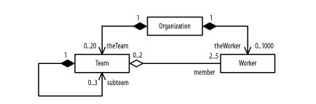

Notice in Figure G that I've done something different with Team. I've created a circular relationship to allow for subteams. Such a circular relationship is known as a reflexive relationship, because it relates two objects of the same class.

Composition

Composition, also known as composite aggregation, is a whole-part relationship between a composite (the whole) and its parts, in which the parts must belong only to one whole and the whole is responsible for creating and destroying its parts when it is created or destroyed. This relationship is often known as a contains-a relationship, because the whole contains its parts. For example, an organization contains teams and workers, and if the organization ceases to exist, its teams and workers also cease to exist. The specific individuals who represent the workers would still exist, but they would no longer be workers of the organization, because the organization would no longer exist. Composition is shown using a filled diamond attached to the class that represents the whole. The relationships between a team, its workers,
LII

and an organization are shown in Figure G. The filled-in diamond at the endpoint of the subteam relationship in Figure G indicates that teams contain their subteams. As a UML rule, composition is used only with binary associations.

Notice how much information is being communicated in Figure G. It shows that an organization may contain 0 to 20 teams and 0 to 1,000 workers. Furthermore, each team has 2 to 5 workers and each worker may be a member of 0 to 2 teams. In addition, a team may contain 0 to 3 subteams.

To determine if you should use an aggregation or composition, ask yourself a few questions. First, if the classes are related to one another, use an association. Next, if one class is part of the other class, which is the whole, use aggregation; otherwise, use an association. For example, Figure G shows that workers are part of a team and organization, teams are part of an organization, and subteams are part of teams. Finally, if the part must belong to one whole only, and the whole is responsible for creating and destroying its parts, use composition; otherwise, simply use aggregation.

For example, Figure G shows that a team and worker must belong to one organization only, and the organization is responsible for determining (or creating and destroying) its teams and workers. It also shows that a subteam must belong to one team only, and the team is responsible for determining (or creating and destroying) its subteams. If this is unclear, keep things simple and use associations without aggregation or composition.

Composition also may be shown by graphically nesting classes, in which a nested class's multiplicity is shown in its upper-right corner and its rolename is indicated in front of its class name. Separate the rolename from the class name using a colon. Figure H uses the graphical nesting of teams and workers in organizations to communicate the same information as shown in Figure G .

Figure H. Alternate form of composition for associations
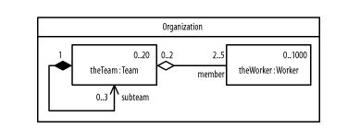

Figure I uses the graphical nesting of subteams within teams to communicate the same information as Figure I and Figure H. The result is a nested class inside a nested class.

Figure I. Doubly nested composition for associations

LIII
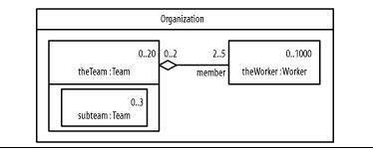

- DEPENDENCY

Sometimes the relationship between a two classes is very weak. They are not implemented with member variables at all. Rather they might be implemented as member function arguments. Consider, for example, the Draw function of the Shape class. Suppose that this function takes an argument of type DrawingContext.
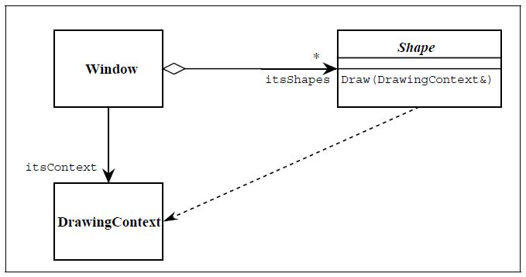

Above figure shows a dashed arrow between the Shape class and the DrawingContext class. This is the dependency relationship. This relationship simply means that Shape somehow depends upon DrawingContext. In C++ this almost always results in a #include.

- Adornments on association: association names, association classes, qualified association, n-ary associations, ternary and reflexive association

- Dependency relationships among classes, notations

- Notes in class diagram, extension mechanisms, metadata, refinements, derived, data, constraint, stereotypes, package & interface notation.

- Object diagram notations and modeling, relations among objects (links)

Interfaces

An interface is a specification of behavior that implementers agree to meet; it is a contract. By realizing an interface, classes are guaranteed to support a required behavior, which allows the system to treat non-related elements in the same way – that is, through the common interface.

LIV
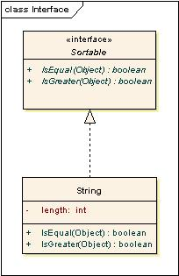

Interfaces may be drawn in a similar style to a class, with operations specified, as shown below. They may also be drawn as a circle with no explicit operations detailed. When drawn as a circle, realization links to the circle form of notation are drawn without target arrows.
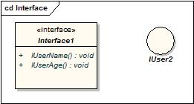

 

 
LV

7

STATE DIAGRAM

Unit Structure

- Introduction
- States
- Events
- Composite States
- Transitions

- INTRODUCTION

This chapter focuses on state diagrams, also known as state chart diagrams, which depict the lifecycle of elements that make up a system. First, we introduce state diagrams and how they are used. Next, we go over states and their details. Finally, we discuss transitions between states and their details. Many details of state diagrams that were not fleshed out in previously are more fully elaborated here, and throughout the chapter, we include suggestions relating to state diagrams.

State modeling is a specialized type of behavioral modeling concerned with modeling the lifecycle of an element. You usually apply state modeling in conjunction with interaction and collaboration modeling to explore the lifecycle of interacting and collaborating elements.

- STATES

As discussed in earlier, as elements communicate with one another within a society of objects, each element has a lifecycle in which it is created, knows something, can do something, can communicate with other elements to request processing of those other elements, can have other elements communicate with it to request processing of it, and is destroyed. A state is a specific condition or situation of an element during its lifecycle. Define the states for your elements. The current state of an element is called its active state, and the element is said to be "in" that state. There are various types of states, including simple, initial, and final states. The next few sections discuss these different types of states.

Simple States

A simple state indicates a condition or situation of an element. For example, the project management system may be in one of the following simple states:

Inactive: Indicates that the project management system is not available to its users, because it is not started or has been shut down.
LVI

Active: Indicates that the project management system has been started and is available to its users.

Suspended: Indicates that the project management system has encountered some severe error, perhaps because it is running low on secondary storage and requires user intervention before becoming active again

Notation:

In the UML, a simple state is shown as a rectangle with rounded corners and labeled with the name of the state or a description of the situation of the element. Following figure shows the various states associated with the project management system.

Simple states
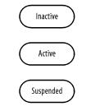

Initial and Final States

An initial state indicates the state of an element when it is created. In the UML, an initial state is shown using a small solid filled circle. A final state indicates the state of an element when it is destroyed. In the UML, a final state is shown using a circle surrounding a small solid filled circle (a bull's eye). Above figure updates with an initial state and final state. A state diagram may have only one initial state, but may have any number of final states

Simple, initial, and final states
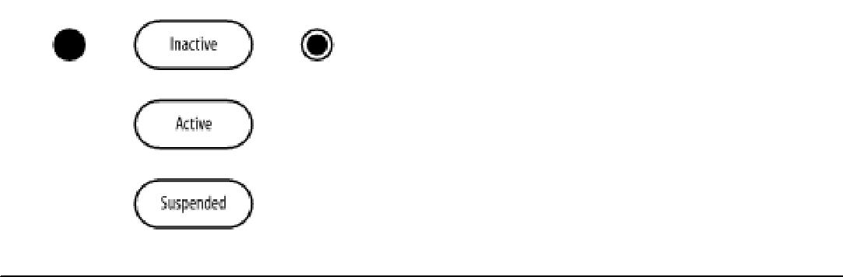

- EVENTS

An event is an occurrence, including the reception of a request. There are a number of different types of events within the UML.

CallEvent. Associated with an operation of a class, this event is caused by a call to the given operation. The expected effect is that the steps of the operation will be executed.

SignalEvent. Associated with a signal, this event is caused by the signal being raised.

TimeEvent. An event cause by expiration of a timing deadline.
LVII

ChangeEvent. An event caused by a particular expression (of attributes and associations)

becoming true.

An event is represented by its name.

For example, the project management system may respond to the following events:

Startup: Indicates that the project management system will become active if it is inactive.

Shutdown:Indicates that the project management system will become inactive if it is active.

Severe Error:Indicates that the project management system has encountered a severe error, perhaps because it is running low on secondary storage, and will become suspended if it is active.

Reset:Indicates that the project management system will become active if it is suspended.

In the UML, an event is described using the following UML syntax:

event_name (parameter_list) [guard]

in which:

event_name:Is the name of the event. An event usually has the same name as an operation of the element to which the state diagram pertains; therefore when the element receives the event, that operation is invoked.

parameter_list: Is optional, and is a comma-separated list that indicates the parameters passed to the event. Each parameter may be an explicit value or a variable. The parentheses are not used when the event does not require any parameters.

guard:Is optional, and indicates a condition that must be satisfied for the transition to fire, or occur. The square brackets are not shown when a guard is not specified.

The UML also allows you to show an event using pseudocode or another language. For example, you can use the syntax of Java, C++, C#, or some other programming language.

Following is an example of an event defined using the syntax just shown. The event informs the project management system to start up:

Startup

If this event requires the user's identification, you can update the event to the following:

Startup (UserID)

If the project management system responds to this event only if it can start up, perhaps if enough memory is available, you can update the transition to the following:

Startup (UserID) [Enough memory is available]
LVIII

- COMPOSITE STATES

A composite state is simply a state that contains one or more statecharts diagrams.

Composite states may contain either:

- a set of mutually exclusive states: literally like embedding a statechart diagram inside a state

- a set of concurrent states: different states divided into regions, active at the same time

A composite state is also called a super-state, a generalized state that contains a set of specialized states called substates.

A composite state (super-state) may be decomposed into two or more lower-level states (sub-states). All the rules and notation are the same for the contained substates as for any statechart diagram. Decomposition may have as many levels as needed.
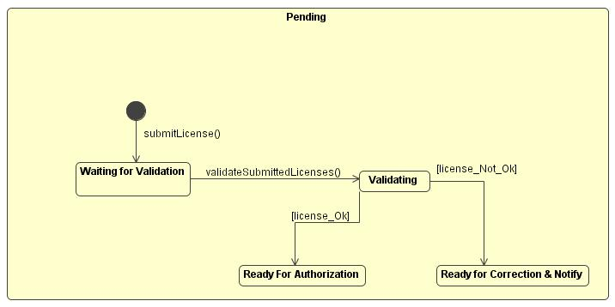

History States: A flow may require that the object go into a trance, or wait state, and on the occurrence of a certain event, go back to the state it was in when it went into a wait state—its last active state. This is shown in a State diagram with the help of a letter H enclosed within a circle.
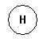

Take the following example.

A criminal investigation starts in the "pending" state. Once it switches to the "Being Actioned" state, it can be in a number of substates. However, at random intervals, the case can be audited. During an audit, the investigation is briefly suspended. Once the audit is complete, the investigation must resume at the state from where it was before the audit. The simple "history notation" (a "H" in a circle) allows us to do this, as follows:
LIX
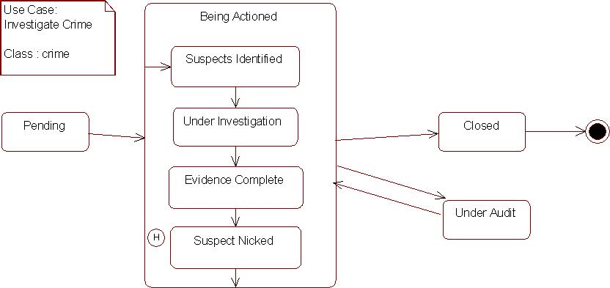

- TRANSITIONS

Given the states of an element, how are they related to one another? Transitions address this question. As discussed earlier, transitions between states occur as follows:

- An element is in a source state.
- An event occurs.

- An action is performed.
- The element enters a target state.

When an event occurs, the transition is said to fire. In the UML, a transition is shown as a solid line from a source state to a target state labeled with the event followed by a forward slash followed by the action, where the event and action are optional and the forward slash is used only if an action is shown.

Simply it is an arrow indicating the Object to transition from one state to the other. The actual trigger event and action causing the transition are written beside the arrow, separated by a slash. Transitions that occur because the state completed an activity are called "triggerless" transitions. If an event has to occur after the completion of some event or action, the event or action is called the guard condition. The transition takes place after the guard condition occurs. This guard condition/event/action is depicted by square brackets around the description of the event/action (in other words, in the form of a Boolean expression).
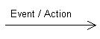

Entry Actions

More than one event can trigger a transition of an object into the same state. When the same action takes place in all events that goes into a state, the action may be written once as entry action.

Notation:

- Use the keyword entry followed by a slash and the actions to be performed every time the state is entered

- Entry actions are part of internal transitions compartment
LX

Exit Actions

The same simplification can be used for actions associated with events that trigger a transition out of a state. They are called exit actions.

Notation:

- Use the keyword exit followed by a slash and the actions performed every time the state is exited

- Exit actions are part of the internal transitions compartment Only when the action takes places every time the state is exited.

For example.
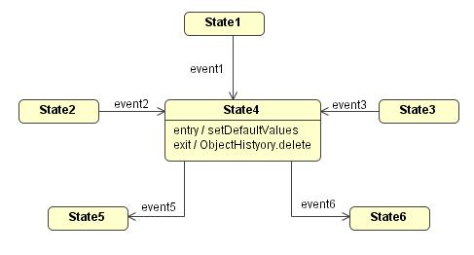

Send Events

Sometimes the object modelled by the statechart needs to send a message to another object, in this case the outgoing event must define which is the receiving object. Also, this event must be caught by the receiving object. A message send to another object is called a send event.

Notation: provide the object name before the action expression with a period separating both
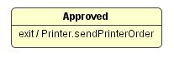

 
LXI

8

SEQUENCE DIAGRAM

Unit Structure

- Introduction
- Notations
- Communication
- Types of Messages
- Conditional Messaging

- INTRODUCTION

A sequence diagram shows elements as they interact over time, showing an interaction or interaction instance. Sequence diagrams are organized along two axes: the horizontal axis shows the elements that are involved in the interaction, and the vertical axis represents time proceeding down the page. The elements on the horizontal axis may appear in any order.

- NOTATIONS

Sequence diagrams are made up of a number of elements, including class roles, specific objects, lifelines, and activations. All of these are described in the following subsections.

Class roles

In a sequence diagram, a class role is shown using the notation for a class as defined in previously, but the class name is preceded by a forward slash followed by the name of the role that objects must conform to in order to participate within the role, followed by a colon. Other classes may also be shown as necessary, using the notation for classes, Class roles and other classes are used for specification-level collaborations communicated using sequence diagrams. Following figure

shows the projectOrganization class role as well as the Project and Report
classes.

Figure A. Class role and two classes
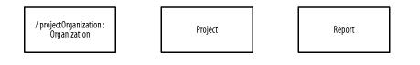

Specific objects

In a sequence diagram, a specific object of a class conforming to a class role is shown using the notation for objects, but the object name is followed by a forward slash followed by the name of the role followed by a colon followed by the class name, all fully underlined. Other objects may also be shown as necessary using the notation for objects.
LXII

Specific objects conforming to class roles and other objects are used for instance-level collaborations communicated using sequence diagrams. Figure B shows that Andy's organization plays the role of an organization that contains a project that is the subject of the report. Figure B also shows anonymous Project and Report objects.

Figure B. Object conforming to a class role
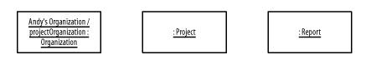

Lifelines

A lifeline, shown as a vertical dashed line from an element, represents the existence of the element over time. Figure C shows lifelines for the class role (projectOrganization) and classes (Project and Report) in Figure A. Lifelines may also be shown for the objects in Figure B.

Figure C. Lifelines
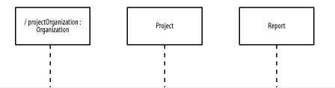

Activations

An optional activation, shown as a tall, thin rectangle on a lifeline, represents the period during which an element is performing an operation. The top of the rectangle is aligned with the initiation time, and the bottom is aligned with the completion time. Figure D shows activations for the class roles in Figure A, where all the elements are simultaneously performing operations. Activations may also be shown for the objects in Figure B.

Figure D. Activations
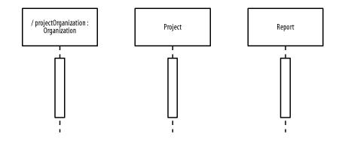
LXIII

- COMMUNICATION

In a sequence diagram, a communication, message, or stimulus is shown as a horizontal solid arrow from the lifeline or activation of a sender to the lifeline or activation of a receiver. In the UML, communication is described using the following UML syntax:

[guard] *[iteration] sequence_number : return_variable := operation_name

(argument_list)

in which:

guard

Is optional and indicates a condition that must be satisfied for the communication to be sent or occur. The square brackets are removed when no guard is specified.

iteration

Is optional and indicates the number of times the communication is sent or occurs. The asterisk and square brackets are removed when no iteration is specified.

sequence_number

Is an optional integer that indicates the order of the communication. The succeeding colon is removed when no sequence number is specified. Because the vertical axis represents time proceeding down the page on a sequence diagram, a sequence number is optional.

return_variable

Is optional and indicates a name for the value returned by the operation. If you choose not to show a return variable, or the operation does not return a value, you should also omit the succeeding colon and equal sign.

operation_name

Is the name of the operation to be invoked.

argument_list

Is optional and is a comma-separated list that indicates the arguments passed to the operation. Each parameter may be an explicit value or a return variable from a preceding communication. If an operation does not require any arguments, the parentheses are left empty.

Example

In some ways, a sequence diagram is like a stack trace of object messages. Below is a sample sequence diagram
LXIV
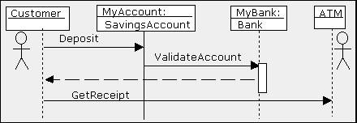

The Sequence diagram allows the person reading the documentation to follow the flow of messages from each object. The vertical lines with the boxes on top represent instances of the classes (or objects).

The label to the left of the colon is the instance and the label to the right of the colon is the class. The horizontal arrows are the messages passed between the instances and are read from top to bottom.

Here

- a customer (user) depositing money into MyAccount which is an instance of Class SavingsAccount.

- Then MyAccount object Validates the account by asking the Bank object, MyBank to ValidateAccount.

- Finally, the Customer Asks the ATM object for a Receipt by calling the ATM‘s operation GetReceipt.

The white rectangle indicate the scope of a method or set of methods occurring on the Object My Bank. The dotted line is a return from the method ValidateAccount.

Recursion (Repetition)

An object might also need to call a message recursively, this means to call the same message from within the message.

- Suppose that cityLocations is defined in the class diagram as a set of one or more apartments or houses

- A letter could be sent to all apartments in a location as shown
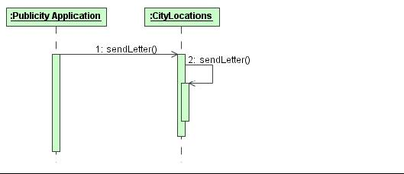

- TYPES OF MESSAGES

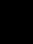 Synchronous Messages

- assumes that a return is needed

- sender waits for the return before proceeding with any other activity
LXV

- represented as a full arrow head

- return messages are dashed arrows
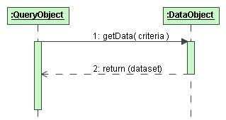

Asynchronous Messages

- does not wait for a return message

- exemplified by signals

- sender only responsible for getting the message to the receiver

- usually modeled using a solid line and a half arrowhead to distinguish
it from the full arrowhead of the synchronous message
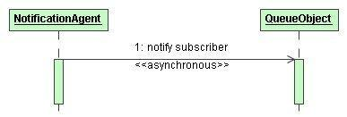

Self-Reference Message

A self-reference message is a message where the sender and receiver are one and the same object.

- in a self-reference message the object refers to itself when it makes the call

- message 2 is only the invocation of some procedure that should be executed
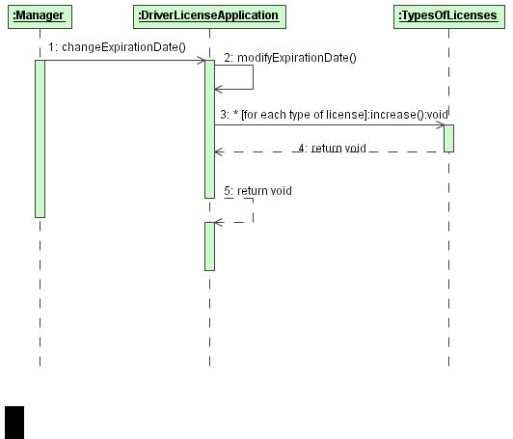

Timed Messages

1) messages may have user-defined time attributes, such as
LXVI

sentTime or receivedTime

- user-defined time attributes must be associated with message numbers

- instantaneous messages are modeled with horizontal arrows

- messages requiring a significant amount of time, it is possible to slant the arrow from the tail down to the head

Object Creation and Destruction

For Example
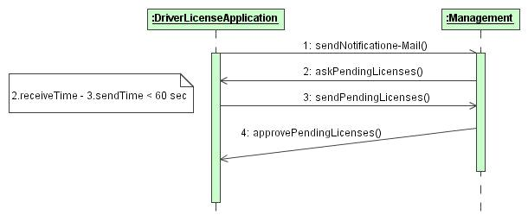

For messages 1, 2 and 3 the time required for their execution is considered equal to zero.

Message 4 requires more time (time > 0) for its execution.

- CONDITIONAL MESSAGING

In a sequence diagram, conditionality (which involves communicating one set of messages or stimuli rather than another set of messages or stimuli) within a generic-form interaction is shown as multiple communications leaving a single point on a lifeline or activation, with the communications having mutually exclusive guard expressions. A lifeline may also split into two or more lifelines to show how a single element would handle multiple incoming communications, and the lifelines would subsequently merge together again.

Following figure shows the Generate Project-Status Report interaction and collaboration description where the GenerateProject-StatusReportHandler class requests that the projectOrganization class role indicate that the project is empty if the project is a newly created or unpopulated project,

and the GenerateProject-StatusReportHandler class requests that the

projectOrganization class role continue generating information for the report element if the project is not a newly created or populated project. In this figure, only the first communication is shown for actually generating the report. If there are no other communications for actually generating the report, the GenerateReport communication may go to the same lifeline as the OutputEmptyProject communication. we use different lifelines in the figure because each lifeline represents a different path of execution.
LXVII

Sequence diagram conditionality within a generic-form interaction
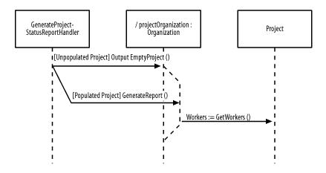

Object Creation: if the object is created during the sequence execution it should appear somewhere below the top of the diagram.

For example.

Alternative A Alternative B
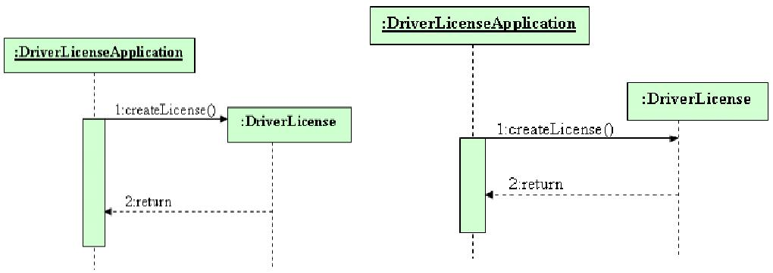

Object Destruction: if the object is deleted during the sequence execution, place an X at the point in the object lifeline when the termination occurs.

For example.


  

 

 

 

